# OWNER

## Log In

1. To log in you will have will have to identify yourself with your assigned mail and password.
2. Click on “Log In” button

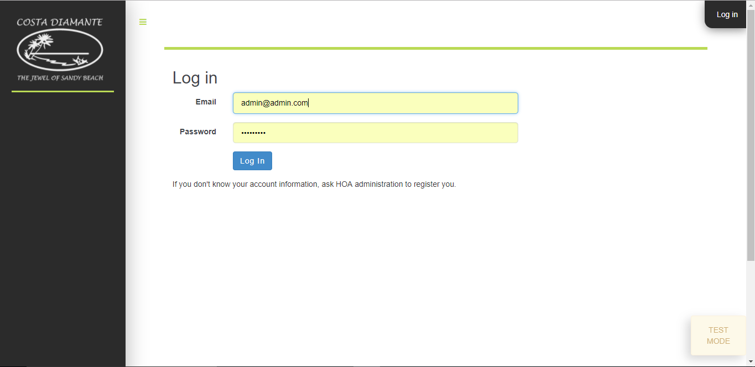

2

1

## Owner Main Screen

This section is shown when you log in, monitoring all the processes corresponding to your condos.

### Condos Lis

Show all the condos that were registered to your account.

### HOA Fees Report By Condo

Shows a list of condos registered to your account that for each one shows a report by condo, total paid by quarter

### History of Visits

History of registered visits in your condos filtered by a range of dates.

1. check visits:

3.1 Select the period of the visit.  
3.2 Click on the button “Search”.  
3.3 To look at the information in details click on “View Notification”.  
3.4 Visit information and payments.

1

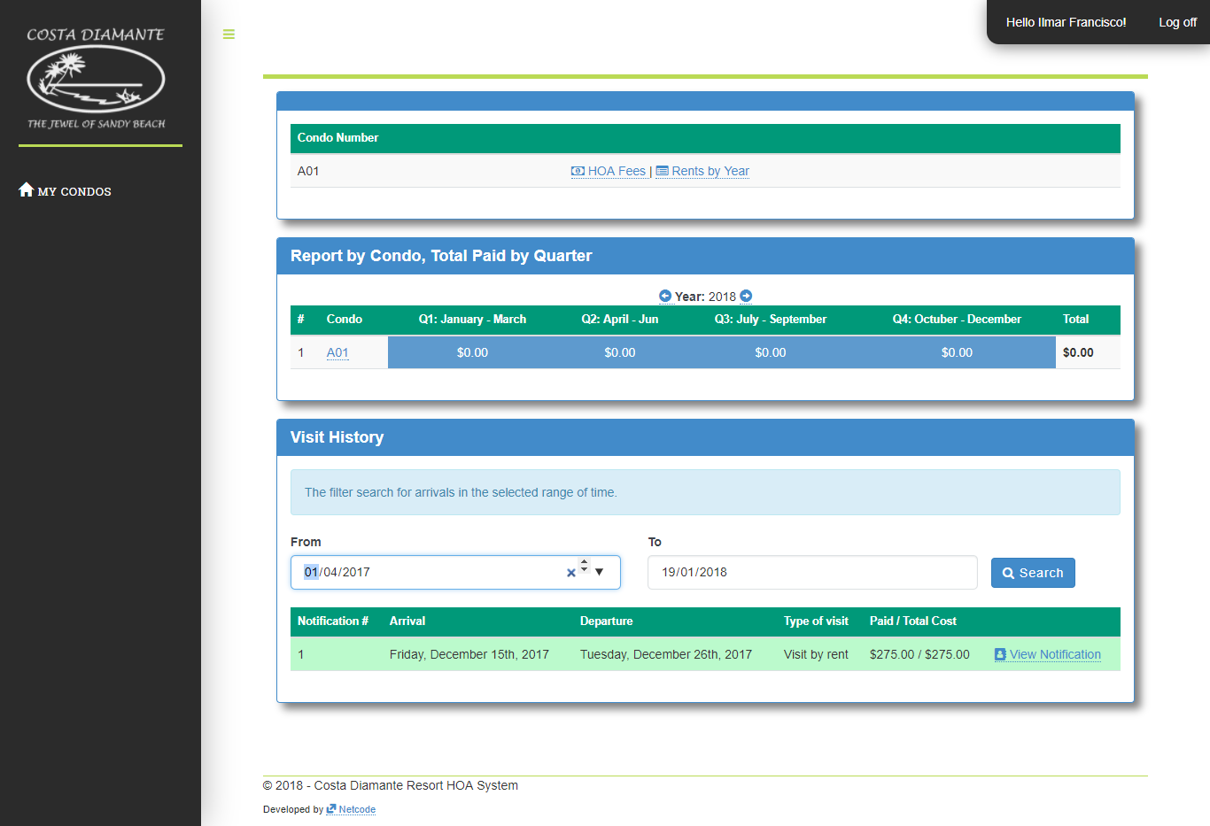

2

3

3.1

3.2

3.3

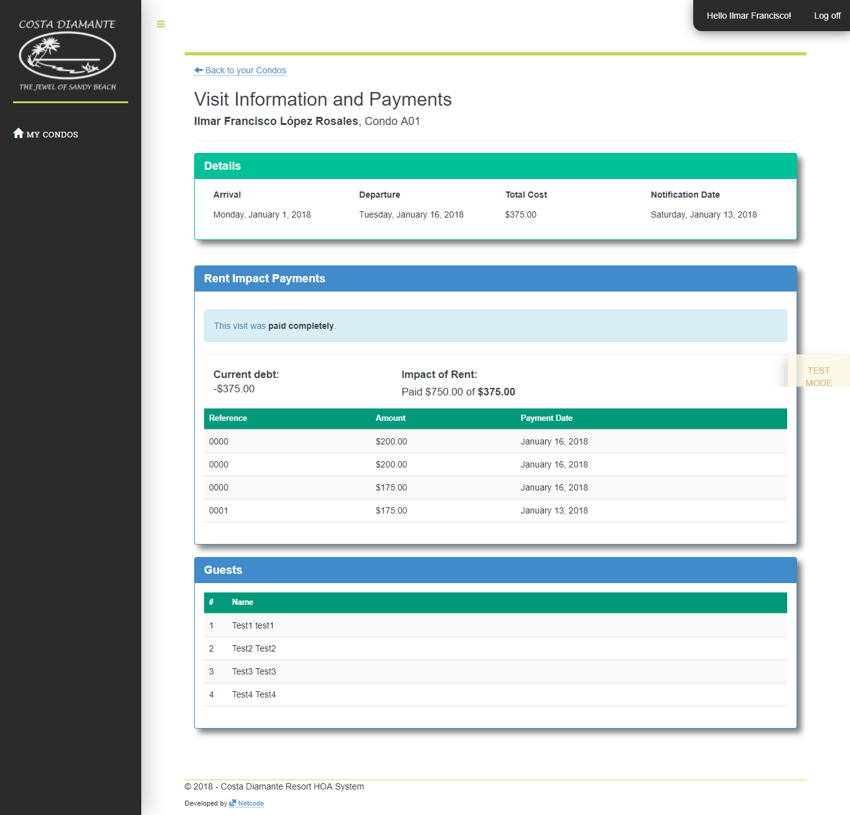

3.4

## HOA Fees Payments

This section is used to list the HOA Fee payments that have been made per quarter.

1. See the HOA Fee payments registered by condo.
   1. To look at the detailed information of your HOA Quotas by condo click on “HOA Fees”.

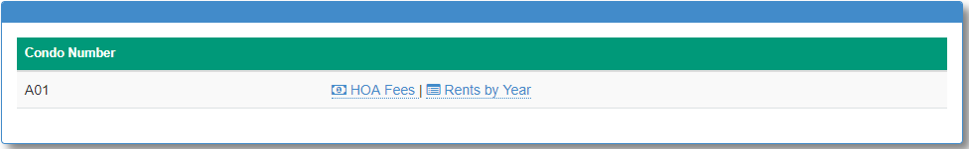

1navigation per year

1. This section offers a year selector for and for each year allows you to select a specific quarter to list all the corresponding HOAFee payments.
   1. Navigation per quarter.
   2. Navigation per year.

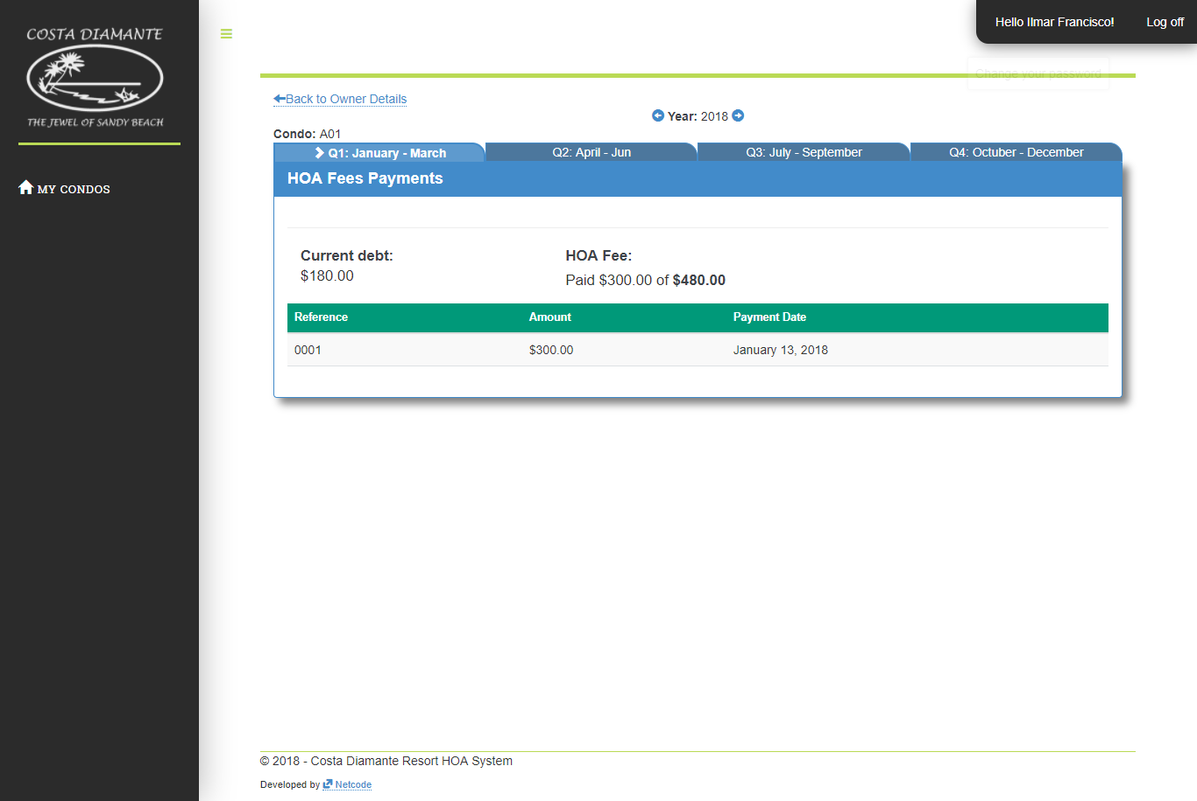

1navigation per year

2navigation per year

## Rents By Year Report

This section corresponds to the selected condo where it offers a year selector, to list the registered visits corresponding to each month. Where it shows a detailed report of the income of the selected year.

1. See the registered rents corresponding to the selected condo.
2. Identify the condo.
3. Once identified click on "Rents by Year".
4. Rents per year report specified by months.

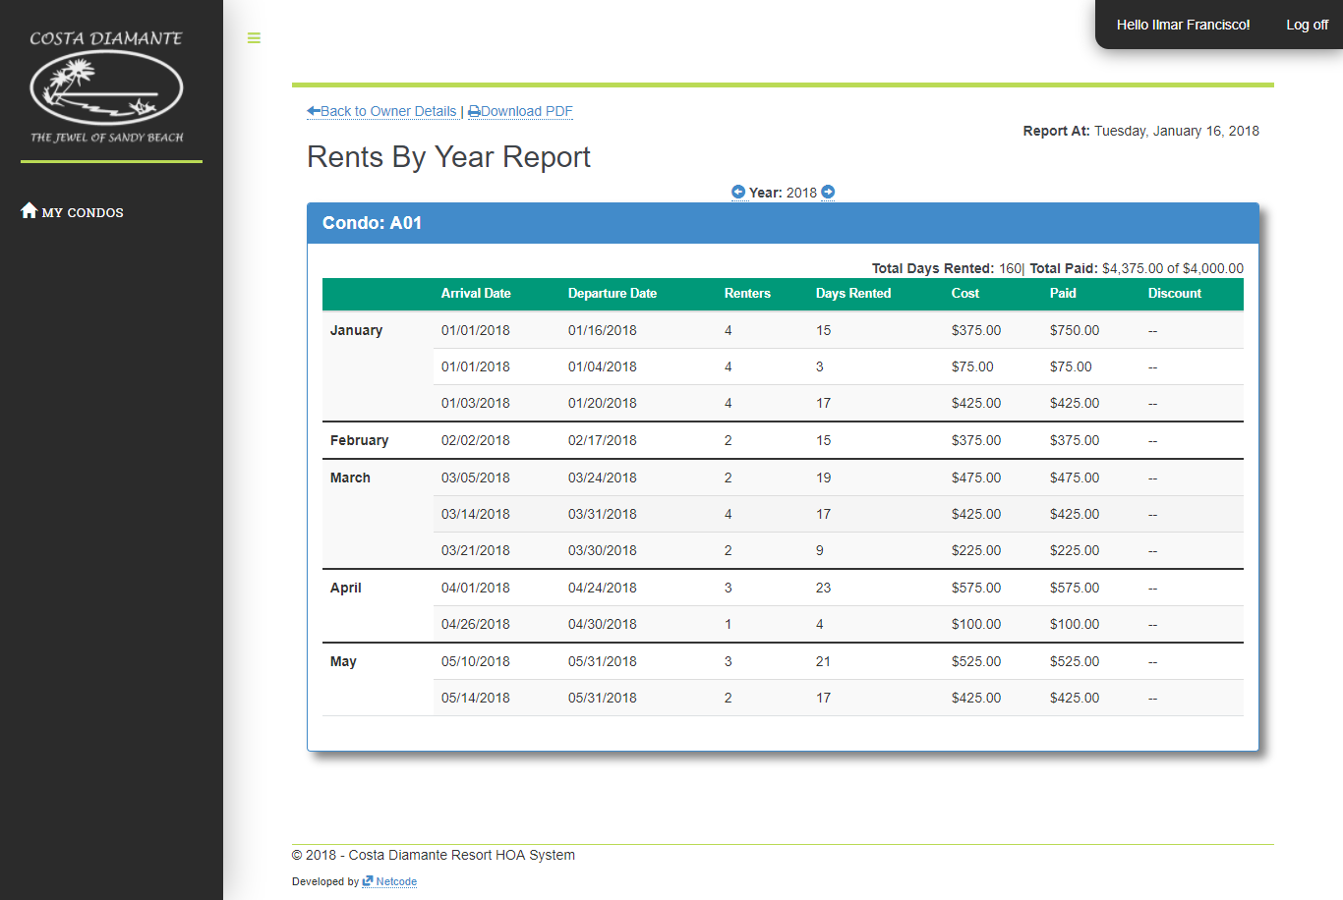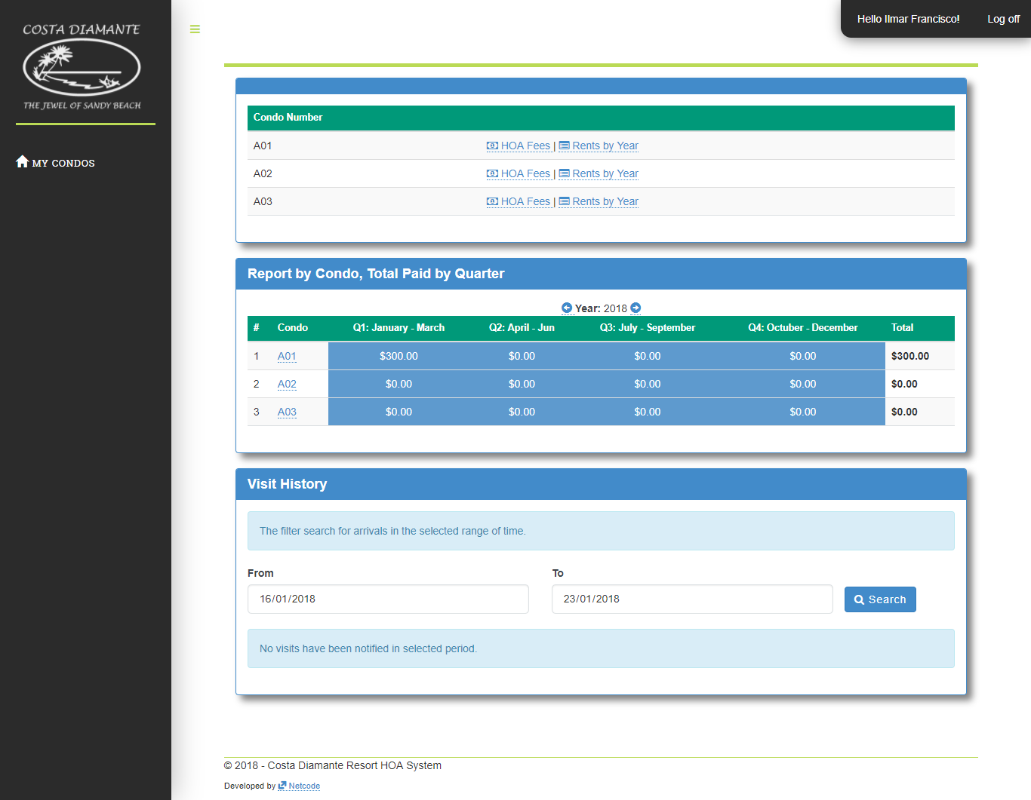

3navigation per year

2navigation per year

1navigation per year

# LANDLORD

## Notify New Visit

This section you have the permissions of an owner, you can also notify new visits.

1. Notify new visit.
   1. Identify the condo.
   2. Once identified click on “Notify New Visit”.
   3. Select the arrival and departure date.
   4. Select the type of visit.
   5. Register visitors.

5.1 Insert the name and last name of visitor.

5.2 To add to the new visitor click on the “Add” button.

5.3 Once finished registering all visitors. Register in the new visit by clicking on the "Register" button.

1. 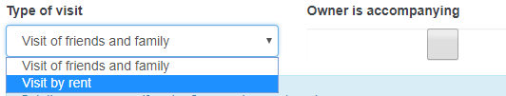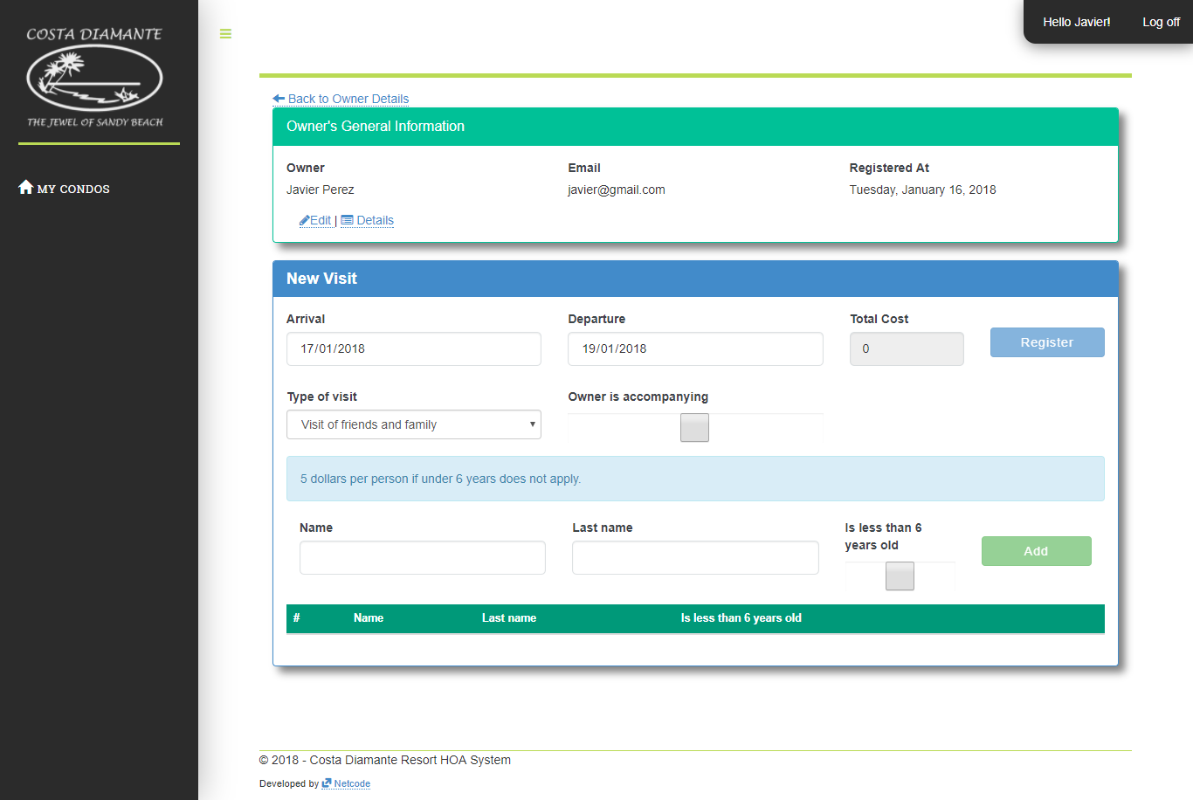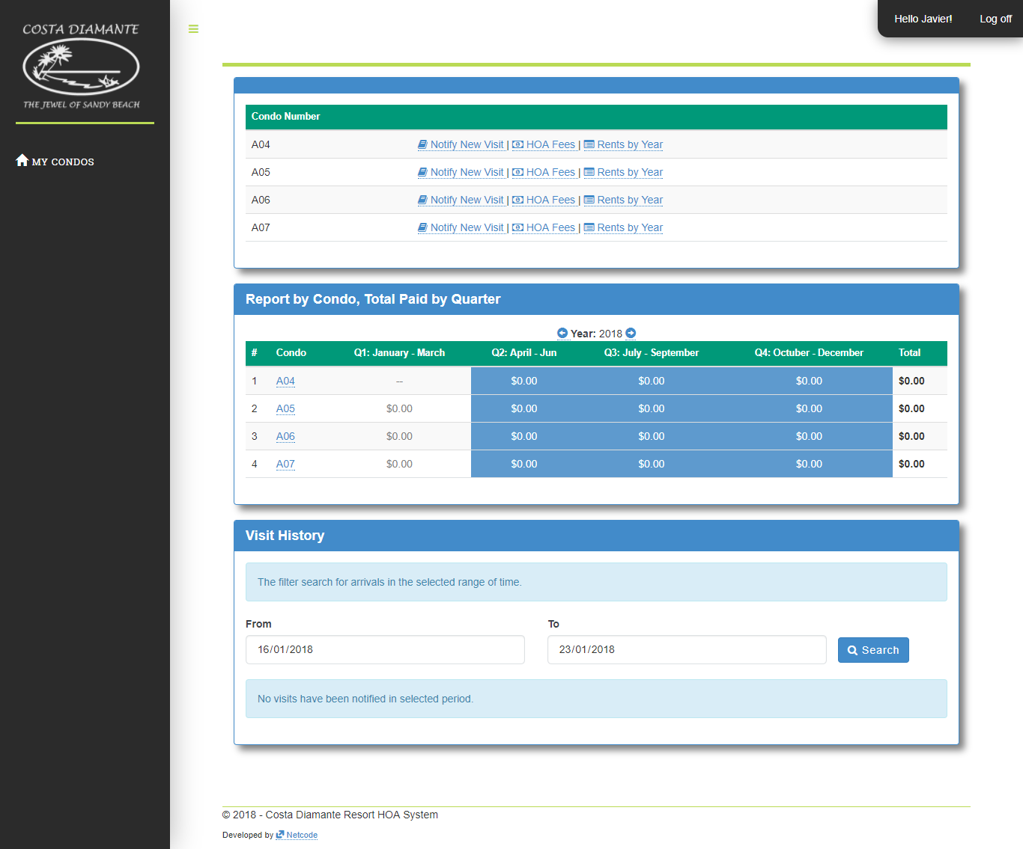

5.3

5.2

5navigation per year

5.1

4navigation per year

3navigation per year

2navigation per year

1navigation per year

# ADMIN

## Owners and Users

This section has full control of the system, where you can register new owners and condos.

### Register and Edit Users

* 1. Register a new owner.
     1. Click on the link “OWNER AND USERS".
     2. Click on the link “Register New Owner / User”.
     3. Enter the data corresponding to the new user.
     4. Choose the type of permission of the new user.
     5. Register the new user.

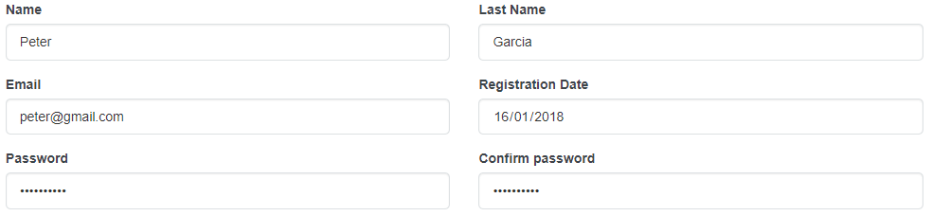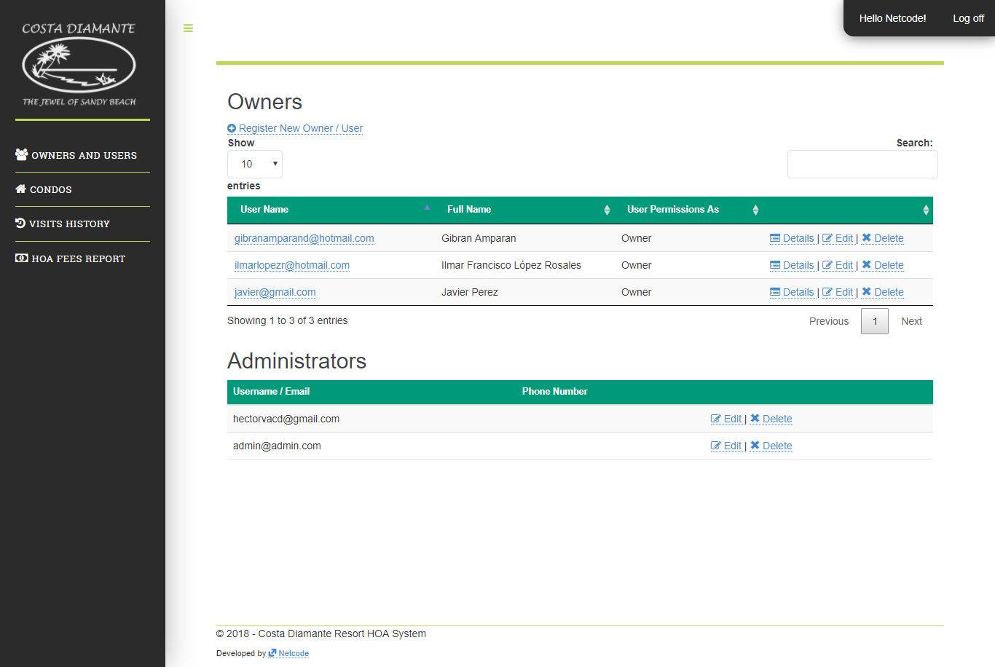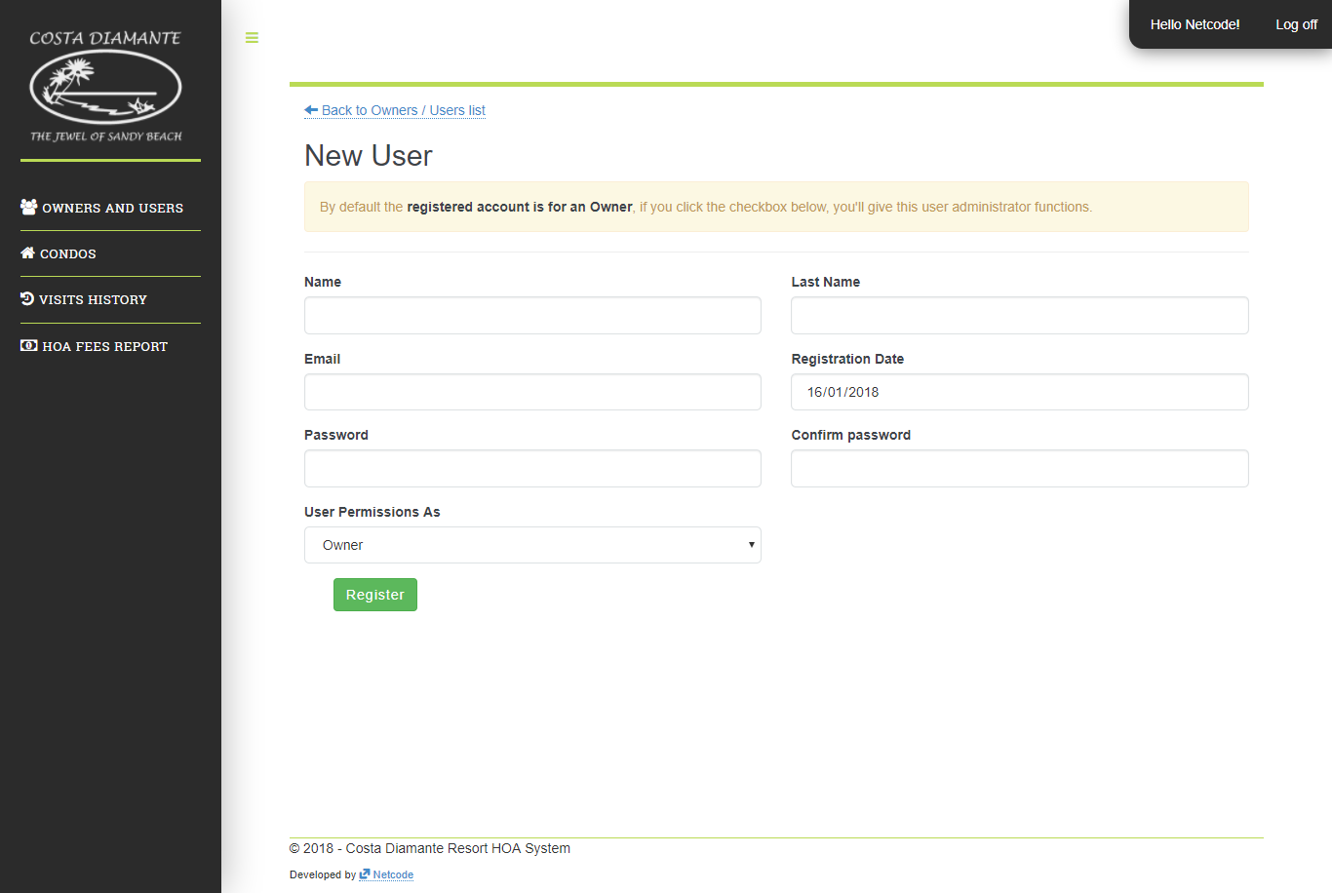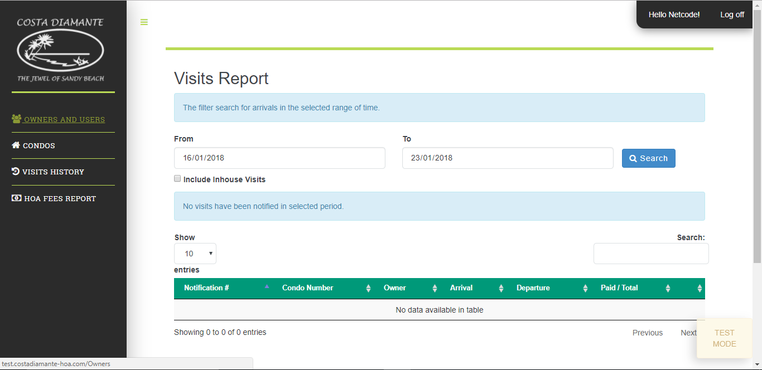

3navigation per year

2navigation per year

1navigation per year

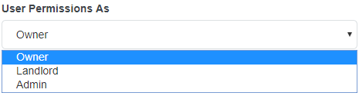

4navigation per year



5navigation per year

* 1. Edit an owner.
     1. Identify the user.
     2. Once identified click on “Edit”.
     3. …

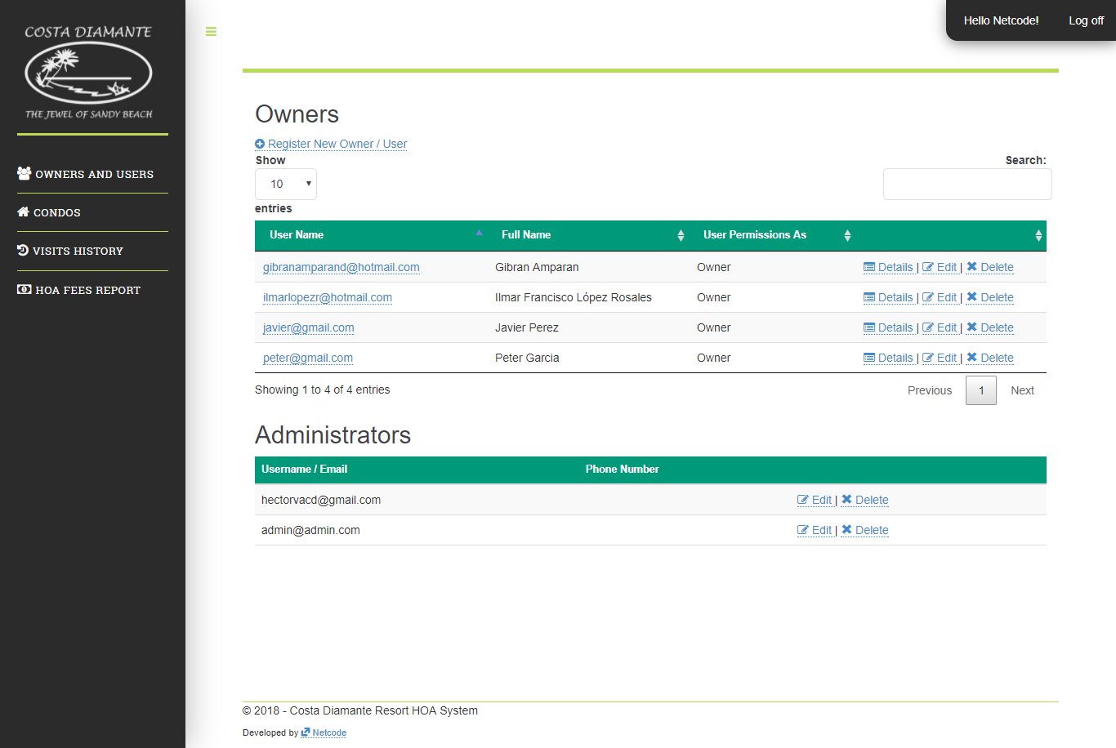

2 per year

1 per year

### Remove Users

## Condos

### Register and Edit New Condo

### Remove

## General Visits History Report

## General HOA Fees Report